CL Reference Implementation

ECN OCAP1.0-N-07.1050-2 Design Review
(MediaAccessHandler Maintenance)

1. Overview
This ECN is preceded by ECN-972 which was "MediaAccessHandler Upgrade". ECN-1050 clarifies some of the questions raised in ECN-972 and proposes the following changes:
- Add a ratings evaluation clarification to section 16.2.1.7.
- Add TV_Y7_FV and MPAA_NA constants to ParentalControlSettings.
- Change MediaAccessHandlerRegistrar.setSignaledBlocking javadoc to allowing OR’ing of TV and MPAA ratings for consistency with the getSignaledBlocking method. Clarified the javadoc.
- Remove the “if and only if” wording from the MediaAccessHandlerRegistrar.setNotifyCondition method as it is too strong and doesn’t reflect the intended meaning.
- Add a getLevel method to BlockedService.
- Add a SecurityException throws clause to the MediaAccessHandlerRegistrar.setNotSignaledBlocking method.
- Add clarification for handling of parental control changes after service selection completes.
- Add MediaAccessHandlerRegistrar.grantMediaAccessAuthorization method.

2. Scope
Work involved for this ECN includes items listed above as well as completing the MediaAccessHandler (ECN-972) 'Signaled Blocking' functionality.
ECN-1037 (AlternativeContentErrorEvent) which is currently in progress deals with Service Context and JMF media presentation management with respect to Parental Control Ratings changes.

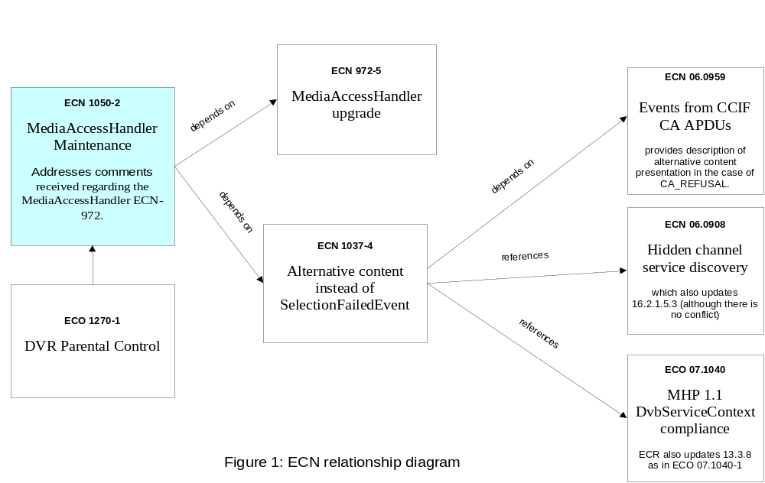

3. Background on ECN-972 and OCAP Parental Control Management
Here is a brief description on the OCAP Parental Control to provide context for ECN-1050.

Parental control in OCAP is based on VBI signaling, content_advisory_descriptor, CCIF feature parameters, and responses from a registered MediaAccessHandler. Conditions for conditional access are determined before conditions for parental control.
The MediaAccessRegistrar.setServiceBlocking method provides a privileged application with the ability to set a parental control blocking for a service based on a start time and duration. This blocking capability is not associated with any in-band or out-of-band signaling mechanism.
The MediaAccessRegistrar.setSignaledBlocking method provides a privileged application with the ability to set a parental control blocking level based on VBI parental rating signaling, as well as the content_advisory_descriptor. A setting made by the setSignaledBlocking method creates a parental rating limit the implementation must adhere to.
When an OCAP Host device contains a V-chip, the chip must be programmed by calls to the setSignaledBlocking method as appropriate. However, the difference between a Host device with or without a V-chip is transparent to OCAP applications with regard to service blocking and generated events. When a Host device contains a V-chip the following rules apply:
- When the setSignaledBlocking method is passed a rating from the U.S. TV Parental Guideline Rating System, i.e. a ParentalControlRatings constant that begins with TV, the V-Chip must be programmed to block using the same rating.
- When the setSignaledBlockingOverride method is passed an over-ride value of 'true' the V-Chip must be over-ridden by programming it with a non-blocking value.
- When the setSignaledBlockingOverride method is passed an over-ride value of 'false' and the V-Chip was over-ridden from a previous call to setSignaledBlockingOverride, the V-Chip must be programmed with the same value it was programmed with before it was over-ridden.

When both a PMT and an AEIT contain a content_advisory_descriptor for the same service and the rating information does not match, the implementation must use the rating information in the AEIT.

In the current implementation, the ParentalControlManager which is the central component of the design, manages PC settings, monitors content ratings, invokes a MediaAccessHandler (if installed), and notifies JMF when content should be blocked or unblocked.
If the underlying Host platform provides V-Chip support, the MPE V-Chip API (TBD) provides access to this functionality. If V-Chip support is included, the ParentalControlManager will use it (instead of directly monitoring VBI XDS itself). If supported, this component will work directly with the MPE Media API to block / unblock content as designated by settings and signaling. Also, it will notify the ParentalControlManager of changes to blocking state so that it can notify the JMF client, which in turn will generate appropriate events.
The MPE Media API functions as it does now, with the additional capability to block / unblock the presentation.
The JMF implementation must listen for block / unblock notifications from the ParentalControlManager and call down to the MPE Media API to block / unblock content. The ParentalControlManager will use JMF MediaTimers to implement BlockedServices, which have a start time and duration for blocking.
The XDS Rating Monitor is responsible for monitoring VBI XDS data for parental rating information, and notifying ParentalControlManager of changes. This would use the same mechanism that is being used to support VBIFilters.
The ParentalControlManager uses the OCAP POD class to query feature parameters. The ParentalControlManager queries feature parameters directly; there is not yet a need for asynchronous notification of change to parameters, although there could be eventually since these may be dynamic.
The Parental Control Manager monitors the content_advisory_descriptor in the PMT and AEIT, and notifies clients when the rating changes. It does this using a PMT Rating Monitor and AEIT Rating Monitor. Note that signaling of the content_advisory_descriptor via AEIT is only supported in profiles 4 and higher, and we are not currently implementing this functionality.
More on the implementation details in section 6 of this document.
Parental control for DVR is covered in a separate ECR (OCAP-DVR-R 1270-1 DVR Parental Control).

4. Parental Control Requirements from ECN-1050-2

R-1: When service components in a presenting service context are newly selected or change for any reason and conditional access is granted, and the change causes presentation to be blocked for parental control purposes the implementation must black-out the video component and disable the audio component in an implementation specific fashion.

R-2: Content blocking for parental control purposes includes implementation responses and default behaviors to settings from the media access handler API; For instance, after service selection completes signaled rating may change or org.ocap.media.BlockedService duration may start or stop, causing the implementation to block or un-block the service based on the Media API rules.

R-3: Implementation responses to parental control in a feature parameter APDU may cause content blocking. Video replacement for parental control blocking is considered alternative content and the implementation must generate an org.ocap.media.AlternativeContentErrorEvent for any service context presenting blocked service components. The reason in the event must be org.ocap.media.AlternativeContentErrorEvent.RATING_PROBLEM.

R-4: The implementation must generate an org.ocap.media.AlternativeMediaPresentationEvent for any JMF player presenting a service component blocked by a parental control. The reason in the event must be org.ocap.media.AlternativeMediaPresentationReasons.RATING_PROBLEM. In this case, the service context or player must retain resources when allowed by resource contention handling rules.
Note: The specific resources mentioned above are not defined. This may include the tuner resource or the HVideoDevice. The intent may be to make the transition from alternative content to normal content as quickly as possible and circumvent re-negotiation of resources.
R-5: When any service component in a presenting service context is blocked, applications bound to the selected service must not be allowed to run. Newly signaled applications in an AIT must not be launched and running applications signaled from a previous service and included in the current service AIT must destroyed.
R-6: When a blocked service is presented as alternative content and is unblocked due to change in parental control status the implementation must present the service and generate a javax.tv.service.selection.NormalContentEvent.

R-7: When conditional access is entitled and parental control does not block presentation the implementation must generate a javax.tv.service.selection.NormalContentEvent in accordance with [31] JavaTV and CA System. In addition, an org.ocap.media.NormalMediaPresentationEvent is generated for JMF players that are CA entitled and are not blocked by parental controls.

R-8: The MediaAccessRegistrar.setSignaledBlocking method provides a privileged application with the ability to set a parental control blocking level based on VBI parental rating signaling defined in EIA-766-A and EIA/CEA-608B, as well as the content_advisory_descriptor defined in SCTE 65. A setting made by the setSignaledBlocking method creates a parental rating limit the implementation must adhere to as defined in EIA/CEA-608B, with the exception of the TV-Y ratings. Blocking any TV-Y rating must automatically block all other TV ratings that are higher in the grid.

R-9: An application that has MonitorAppPermission ("mediaAccess") can implement a MediaAccessHandler to prevent the presentation of A/V service components when a new service is selected or when the conditions of A/ V service components presentation changes (ex: PMT change). A registered MediaAccessHandler can assert parental control constraints using the media access handler API defined in OCAP 1.0 Media API.

5. Flowcharts
When a MediaAccessHandler is registered and service components are pending change the implementation must adhere to the flow chart-1 MediaAccessHandler Service Change Process. When a MediaAccessHandler is registered and a presenting service parental control status changes the implementation must adhere to the flow chart-2 MediaAccessHandler Parental Control Change Process. Parental control status for purposes of MediaAccessHandler notification include:
- Program rating changes based on VBI or content_advisory_descriptor signaling.
- A BlockedService has been set by the MediaAccessHandler and the start-time is encountered

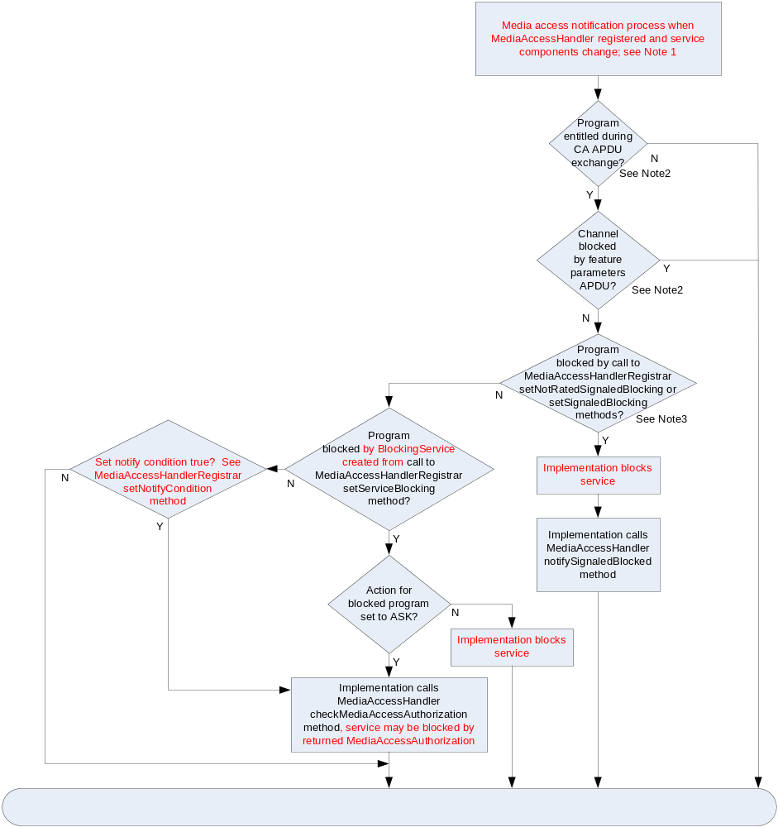

Flow chart-1 MediaAccessHandler Service Change Process
Note1: Service or service component changes for a service context or discrete player occur when different components are selected, CA entitlement is granted, PMT version changes, or resources become available.
Note2: See [4] CableCARD 2.0 specification.
Note3: See [11] EIA/CEA 608B specification

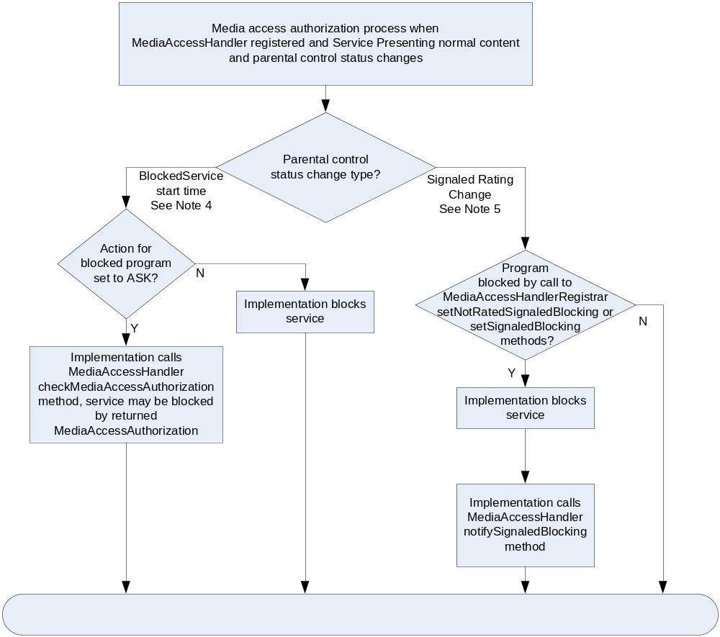

Flow chart-2 MediaAccessHandler Parental Control Change Process
Note 4: A BlockedService is created by a privileged application when calling the MediaAccessHandlerRegistrar.setServiceBlocking method.
Note 5: A signaled rating change includes a change in VBI rating or content_advisory_descriptor signaling.

6. Implementation Details
Figure below shows the components and relationships among them for the base (non-DVR) case. Standard OCAP components are shown in white, implementation components are shown in grey, and MPE components are shown with cross-hatches.
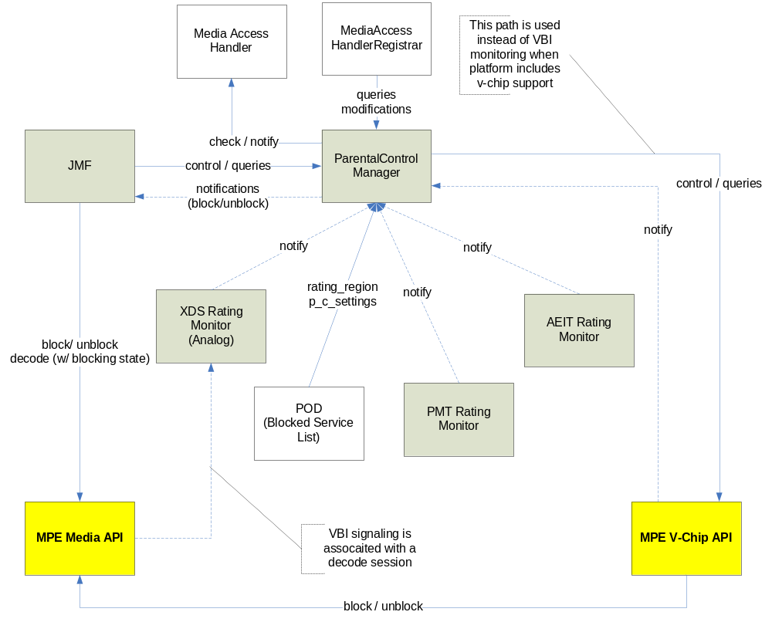

The Parental Control Manager is the “brains” behind PC functionality. It has these responsibilities:
- Maintain the current PC settings (e.g., rating levels, blocked services, and overrides), as ascribed by the MediaAccessHandlerRegistrar.
- Parse CCIF p_c_settings feature parameter to determine services blocked by the CableCard™.
- Monitor PC signaling from these sources:
- VBI XDS – for analog programs
- content_advisory_descriptor – from PMT or AEIT.
- Notify client (JMF) when current program should be blocked / unblocked.
The main clients of this manager are:
- MediaAccessHandlerRegistrar provides most of its functionality by forwarding method calls to this manager.
- JMF receives callback notifications when presentation should be blocked and unblocked.
Most Parental Control Manager implementation files are found in com.vidiom.impl.media.access.
Parental Control Manager follows the established Manager idiom in the Vidiom implementation of the OCAP stack. That is:
- It has an interface, ParentalControlManager, that defines the public interface to the manager and which resides in the com.vidiom.impl.manager package and extends the Manager interface.
- In the mgrmgr.properties file, there is a property that specifies the implementation class of this manager interface for the base implementation:
ParentalControlManager=com.vidiom.impl.media.access.ParentalControlManagerImpl
In order to support integration testing of JMF with the Parental Control Manager, there will be a “canned” implementation of ParentalControlManager (i.e., CannedParentalControlManager) that will be used to force scenarios that would be hard to reproduce with a “real” ParentalControlManager. Like other canned managers, this will be installed as part of the JUnit test setup.

+getServiceBlockingMonitor()
+registerMediaAccessHandler()
+setNotifyCondition()
+getNotifyCondition()
+setSignaledBlocking()
+getSignaledBlocking()
+setNotRatedSignaledBlocking()
+getNotRatedSignaledBlocking()
+setSignaledBlockingOverride()
+getSignaledBlockingOverride()
+setServiceBlocking()
+removeServiceBlocking()
+setServiceBlockingOverride()
+getServiceBlockingOverride()
ParentalControlManagerImpl
+stop()
+setVideoDevice()
+getRate()
+getMediaTime()
+setMediaTime()
+freeze()
+resume()
+setRate()
+select()
+getNativeHandle()
Session
VChipManager
+setSignaledBlocking()
+setSignaledBlockingOverride()
+setNotRatedSignaledBlocking()
+addRatingCallback()
+removeRatingCallback()
BlockedService
+BlockedService()
+getStartTime()
+getDuration()
+getService()
+isAskMediaAccessHandler()
ParentalControlManager
BlockingMonitor
BlockingMonitorImpl
+addCallback()
+dispose()
+getBlockingReason()
+removeCallback()
AEITRatingMonitor
+getRating()
+addCallback()
+removeCallback()
PMTRatingMonitor
+getRating()
+addCallback()
+removeCallback()
XDSRatingMonitor
+getRating()
+addCallback()
+removeCallback()
POD
...
+getHostFeatureList()
+getHostParam()
To monitor rating changes if signaled
in AEIT for digital service.
If platform has native support for
V-Chip, this manager is used to
set signaled blocking levels.
Monitors are created and
added to the list by
getServiceBlockingMonitor().
This is the Session
that is being
monitored.
To monitor rating
changes if
siangled in the PMT
for digital service.
This associates a
BlockedService, if
there is one.
To access
p_c_settings from
the CableCard.
If the monitored
service is analog,
an XDSMonitor is
used to monitor
rating changes.
-xdsMonitor
0..1
-aeitRatingMonitor
0..1
-pmtRatingMonitor
0..1
-blockedSvc
0..1
-monitors
0..*

ParentalControlManagerImpl
This abstract class implements the ParentalControlManager interface. Here are some key features:
- It keeps the current signaled blocking state.
- It keeps a list (monitors) of all the BlockingMonitors that have been created via the getBlockingMonitor method.
- Since this is an abstract base class, it will never be instantiated.
Figure below is a further breakdown of the Parental Control Manager Implementation as it pertains to XDS monitoring and V-chip programming / monitoring. Since the V-chip monitoring overlaps XDS functionality (they both monitor VBI for ratings information), these two pieces of functionality will be mutually exclusive. As such, each will be implemented as a subclass of the main ParentalControlManagerImpl class. The ParentalControlManagerImpl will serve as an abstract base class with the majority of the functionality implemented there. However, it will not be instantiated directly. Only its subclasses (XDSParentalControlManager and VChipParentalControlManager will be instantiated using the Vidiom manager idiom.
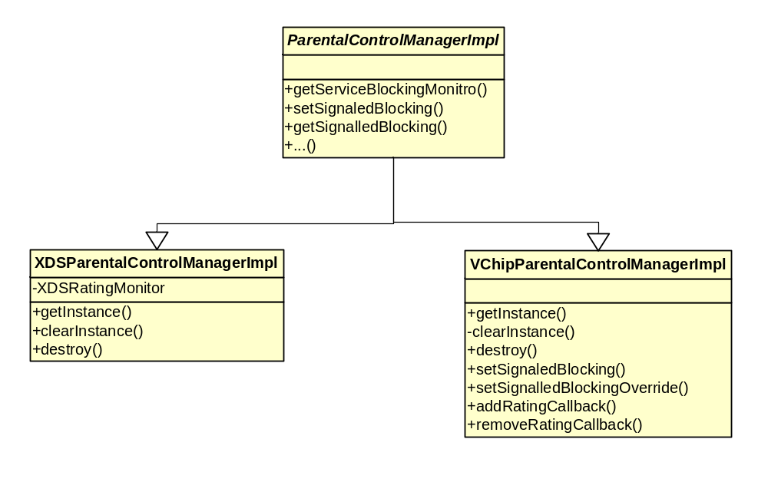

XDSParentalControlManagerImpl
This class extends the ParentalControlManagerImpl class and is instantiated as the ParentalControlManager implementation on platforms that do NOT support VChip. Here are some key features:
- It implements the Vidiom manager idiom by providing getInstance and destroy methods
- Implements XDS monitor functionality using the VBIFilter mechanism

VChipParentalControlManagerImpl
This class extends the ParentalControlManagerImpl class and is instantiated as the ParentalControlManager implementation on platforms that support V-Chip. Here are some key features:
- It implements the Vidiom manager idiom by providing getInstance and destroy methods
- It overrides the setSignaledBlocking and setSignaledBlockingOverride methods to allow for programming of the V-Chip.
- It implements the add/removeRatingCallback methods to handle V-Chip ratings change callbacks

Note: For now we will only be implementing XDSParentalControlManagerImpl (assume a platform with no V-Chip).

BlockingMonitorImpl

The Blocking Monitor has the following features:
- Keeps a reference (player) to the ServicePlayer for which it was created.
- Uses the org.ocap.hardware.pod.POD to retrieve CCIF feature parameters for p_c_settings. If a service is blocked in this manner, it can only be unblocked if the p_c_settings are changed to allow the service.
- If the XDSParentalControlManagerImpl is in use and the service is analog, it uses an XDSRatingMonitor to monitor content rating changes (xdsMonitor).
- If the service is digital, it uses a PMTRatingMonitor (pmtMonitor) to monitor content rating changes that arrive through the PMT. And it uses an AEITRatingMonitor (aeitMonitor) to monitor rating changes that arrive through AEIT signaling. If ratings are signaled in both, the AEIT takes precedence over the PMT.
- If the service has a corresponding BlockedService, it will keep an association to the BlockedService (blockedSvc). In this case, it will use MediaTimers to determine when the service should be blocked and unblocked.

JMF and ServiceContext Refactoring
The ServiceContext is refactored to accommodate event delivery as specified in ECN-972 and ECN-1050. The ServiceContext is refactored to block applications when presentation is blocked. There is already a mechanism to notify the ServiceContext about session changes. This mechanism is modified to return a Session, not just a native handle. From the Session, the ServiceContext will be able to get the BlockingMonitor associated with the Session and add itself as a listener.
Per ECN-1037 the ServiceContext will need to deliver AlternativeContentErrorEvent when service selection fails due to signaled ratings info. ServiceContext also needs to respond to any subsequent changes in ratings information and deliver appropriate events to the application layer.

7. Platform-independent code changes
All the code changes for this ECN are expected to be in the Java layer only. The existing ParentalControlManagerImpl.java file is modified to include signaled blocking functionality.
Additional files will be added in com.vidiom.impl.media.access to support VBI-XDS and PMT-CAD monitoring for ratings extraction.

8. Platform-dependent code changes
No code changes are necessary in the MPE OS layer. All the required changes to Media API to support blocking/unblocking of media are in place.

9. Current state
Service blocking support (implemented as part of ECN-972) is complete.

Signaled blocking support: PMT-CAD extraction is code complete and has been (tunetest xlet) tested on the simulator platform using SoftOC generated test transport streams to validate ratings info extraction.
VBI-XDS extraction is code is 80% complete. Some clean-up remains.
Note: The simulator does not support analog channels; hence testing can only be done on 8300HD STB which supports VBI data extraction from analog sources.

10. Remaining work
- Work items listed in overview section of this document
- Finish XDSRatingsMonitor implementation
- Integrate PMTRatingsMonitor and XDSRatingsMonitor with ParentalControlManagerImpl
- Implement XDSParentalControlManagerImpl
(Simulation of V-Chip functionality is deferred to a later time)
- Ratings change related signaling needed to support ECN-1037 AlternativeContentErrorEvent
- JUnit development

11. Testing

11.1 JUnit
Currently following JUnit tests exist for MediaAccessHandler. Will be adding new tests for SignaledBlocking functionality.

SecurityException (Permissions) Tests:
1. testRegisterMediaAccessHandler_SecurityException()
2. testRemoveServiceBlocking_SecurityException()
3. testSetNotifyCondition_SecurityException()
4. testSetNotRatedSignaledBlocking_SecurityException()
5. testSetServiceBlocking_SecurityException()
6. testSetServiceBlockingOverride_SecurityException()
7. testSetSignaledBlocking_SecurityException()
8. testSetSignaledBlockingOverride_SecurityException()

IllegalArgumentException Tests:
1. testSetSignaledBlocking_IllegalArgumentException()
2. testSetNotRatedSignaledBlocking_IllegalArgumentException()
3. testSetServiceBlocking_IllegalArgumentException()
4. testRemoveServiceBlocking_IllegalArgumentException()

Other Tests:
1. testGetSignaledBlockingDefaultValue()
2. testSetGetSignaledBlocking()
3. testSetGetSignaledBlockingOverride()
4. testSetGetNotifyCondition()
5. testSetGetServiceBlockingOverride()

There is a CannedMediaAccessHandler implementation to emulate a MonApp implementing MediaAccessHandler interface.

MediaAccessHandlerRegistrarImplTest includes the following tests:
1. testSingleton()
2. testMediaAccessHandlerCalled()
3. testMediaAccessHandlerCalledRegisterTwice()
4. testRegisterMediaAccessHandlerNullClears()

BlockedServiceTest includes the following tests:
1. testBlockedService_Normal()
2. testBlockedService_NullStartTime()
3. testBlockedService_NullService()
4. testBlockedService_ZeroDuration()
5. testGetStartTime()
6. testGetDuration()
7. testGetService()
8. testIsAskMediaAccessHandler()

ParentalControlManagerImplTest includes the following tests:
1. testDestroy()
2. testGetInstance()
3. testRegisterMediaAccessHandler_Nullify()
4. testRegisterMediaAccessHandler_AddOnce()
5. testRegisterMediaAccessHandler_AddTwice()
6. testCreateBlockingMonitor()
7. testBlockingMonitor_setCallback()
8. testSetGetNotifyCondition()
9. testServiceBlockingOverride_Default()
10. testServiceBlockingOverride_Enable()
11. testServiceBlockingOverride_EnableBadRange()
12. testServiceBlockingOverride_Disable()
13. testGetVChipBlockingSupport()
14. testServiceBlocking_InitialState()
15. testServiceBlocking_SetNullArray()
16. testServiceBlocking_RemoveNullArray()
17. testServiceBlocking_SetOnceEmpty()
18. testServiceBlocking_SetOnce1()
19. testServiceBlocking_SetOnce2()
20. testServiceBlocking_SetTwice()
21. testServiceBlocking_SetForSameService()
22. testServiceBlocking_Remove()
23. testSetSignaledBlocking_IllegalArgumentException()
24. testSetGetSignaledBlocking()
25. testSetNotRatedSignaledBlocking_IllegalArgumentException()
26. testSetGetNotRatedSignaledBlocking()
27. testSetGetSignaledBlockingOverride()

VChipManagerImplTest includes the following tests:
1. testGetVChipBlockingSupport()
2. testSetGetSignaledBlocking()
3. testSetNotRatedSignaledBlocking_IllegalArgumentException()
4. testSetNotRatedSignaledBlocking()
5. testSetSignaledBlockingOverride()
6. testAddRemoveRatingCallback()

11.2 CTP

Currently following CTP tests exist for MediaAccessHandler. (Didn't find these in Subversion. But they exist in the CTP test source we have from November, 2007 (Eval-M))

1. org.ocap.media.MediaAccessHandlerRegistrar.10
* Retrieve the instance of MediaAccessHandlerRegistrar by calling the
* getInstance() method. Check that no exception is thrown and that this
* MediAccessHandlerRegistrar instance is non null.

2. org.ocap.media.MediaAccessHandlerRegistrar.20
* Call twice the getInstnace of MediaAccessHandlerRegistrar and check
* that the both MediaAccessHandlerRegistrar are the same instance.

3. org.ocap.media.MediaAccessHandlerRegistrar.30
* When registerMediaAccessHandler(null) with the correct PermissionFile
* (MonitorAppPermission(mediaAccess)).Check that no exception is thrown
* and above all no securityException.

4. org.ocap.media.MediaAccessHandlerRegistrar.40
* When registerMediaAccessHandler(null) without the correct
* PermissionFile (MonitorAppPermission(mediaAccess)).Check that the
* expected SecurityException is thrown.

These tests are very basic and do not appear to be testing the actual functionality of the MediaAccessHandler. Will need to come up with scenarios to test the core functionality.

